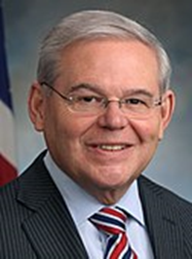
Senator Bob Menendez
(D)
www.menendez.senate.gov
Offices

Newark
One Gateway Center, Suite 1100
Newark, New Jersey 07102
973.645.3030
973.645.0502 (fax)

Barrington
208 White Horse Pike, Suite 18
Barrington, New Jersey 08007
856.757.5353
856.546.1526 (fax)

Washington
528 Hart Senate Office Building
Washington, D.C. 20510
202.224.4744
202.228.2197 (fax)

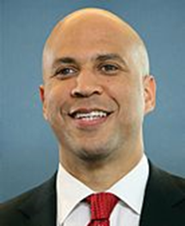
Senator Cory Booker
(D)
www.booker.senate.gov

Offices

Washington Office

717 Hart SOB
Washington, DC 20510
(202) 224-3224

Newark

One Gateway Center
23rd Floor
Newark, NJ 07102
(973) 639-8700

Camden

One Port Center
2 Riverside Dr., Suite 505
Camden, NJ 08103
(856) 338-8936

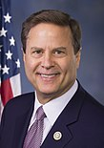
Rep. Donald Norcross
(D, 1st district)
www.house.gov/norcross
Washington Office
2437 Rayburn HOB
Washington, DC 29515
(202) 255-6501
Cherry Hill Office
10 Melrose Avenue
Suite 210
Cherry Hill, NJ 08003
(856) 477-7000

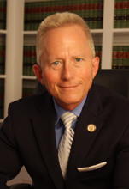
Rep. Jeff Van Drew
(R, 2nd district)
www.house.gov/vandrew
Washington Office
331 Cannon HOB
Washington, DC 20515
(202) 225-6572
Mays Landing Office
5914 Main Street
Suite 103
Mays Landing, NJ 08330
(609) 625-5008
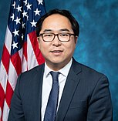
Rep. Andy Kim
(D, 3rd district)
www.house.gov/kim
Washington Office
1516 Longworth HOB
Washington, DC 20515
(202) 225-4765
Marlton Office
535 East Main Street
PO Box 543
Marlton, NJ 08053
Toms River Office
33Washington Street
PO Box 728
Toms River, NJ 08754
(732) 504-0490
Willingboro Office
429 John F. Kennedy Way Box 9
Willingboro, NJ 08046
(856) 703-2700

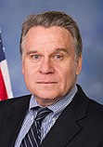
Rep. Chris Smith
(R, 4th district)
www.house.gov/chrissmith
Washington Office
2373 Rayburn HOB
Washington, DC 20515
Monmouth County Office
112 Village Center Drive Second Floor
Freehold, NJ 07728
(732)780-3035
Ocean County Office
405 Route 539
(Pinehurst Road)
Plumsted, NJ 08514
(609) 585-7878
Mercer County Office
4573 South Broad Street
Hamilton, NJ 08620
(609) 585-7878

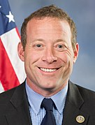
Rep. Josh Gottheimer
(D, 5th district) www.house.gov/gottheimer
Washington Office
213 Cannon HOB
Washington, DC 20515
(202) 225-4465
Glen Rock Office
65 Harristown Road,
Suite 104
Glen Rock, NJ 07452
(201) 389-1100
Newton Office
93 Spring Street
Suite 408
Newton, NJ 07860
(973) 940-1117

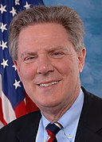
Rep. Frank Pallone
(D, 6th district)
www.house.gov/pallone
Washington Office
2107 Rayburn HOB
Washington, DC 20515
(202) 225-4671
Long Branch Office
504 Broadway
Long Branch, NJ 07740
(732) 517-1140
New Brunswick Office
67/69 Church Street
New Brunswick, NJ 08901
(732) 249-8892

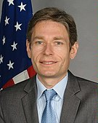
Rep. Tom Malinowski
(D, 7th district)
www.house.gov/malinowski
Washington Office
426 Cannon HOB
Washington, DC 20515(202) 225-5361
Somerville Office
75-77 N Bridge Street
Somerville, NJ 08876
(908) 547- 3307

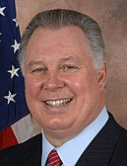
Rep. Albio Sires
(D, 8th district)
www.house.gov/sires
Washington Office
2268 Rayburn HOB
Washington, DC 20515
(202) 225-7919
Elizabeth Office
800 Anna Street
Elizabeth, NJ 07201
(908)802-0692
Jersey City Office
257 Cornelison Ave
Jersey City NJ 07203
(201) 309-0301
West New York Office
5500 Palisade Avenue
Suite A
West New York, NJ 07093
(201) 558-0800

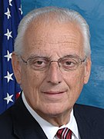
Rep. Bill Pascrell
(D, 9th district)
www.house.gov/pascrell
Washington Office
2409 RHOB
Washington, DC 20515 (202) 225-5751
Englewood Office
2-10 North Van Brunt St.
Englewood, NJ 07631
(201) 935-2248
Lyndhurst Office
367 Valley Brook Ave
Lyndhurst, NJ 07071
(201) 935- 2248
Passaic Office
330 Passaic Street
Passaic, NJ 07055
(973) 472-4510
Paterson Office
200 Federal Plaza
Suite 500 Robert A. Roe Federal Building
Paterson, NJ 07505
(973) 523-5152

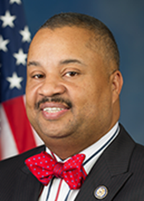
Rep. Donald Payne Jr.
(D, 10th district)
www.house.gov/payne
Washington Office
103 Cannon HOB
Washington, DC 020515
(202) 225-3436
Newark Office
60Nelson Place, 14th Floor
LeRoy F. Smith, Jr Public Safety Building
Newark, NJ 07102
(973)645-3213
Hillside Office
1455 Liberty Avenue
Hillside, NJ 07205
(862) 229-2994
Jersey City Office
253 Martin Luther King Drive
Jersey City, NJ 07305
(201)369-0392

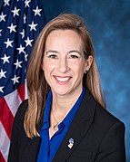
Rep. Mikie Sherrill
(D, 11th district)
www.house.gov/sherrill
Washington Office
1208 Longworth HOB
Washington, DC 20515
(202) 225-5034
Parsippany Office
8 Wood Hollow road
Suite 203
Parsippany, NJ 07054
(973) 526-5668

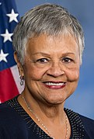
Rep. Bonnie Watson Coleman
(D, 12th district)
www.house.gov/watson-coleman
Washington Office
2442 Rayburn HOB
Washington, DC 20515
(202) 225-5801
Ewing Office
850 Bear tavern Road, Suite 201
Ewing, NJ 08628
(609) 883-2093

as of April 29, 2020

